IT SUPPORT
Houston Medical Imaging

The King guide - Techschedule
- Calendar Page – Break schedule calendar

Problem
- How to create a break schedule in the King?

Solution
- When you log into the King, on the left-hand side under MODULE SELECTION choose TECHSCHEDULE module.
- Under MODULE MENU, please choose CALENDAR.
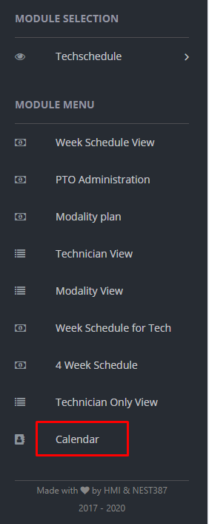
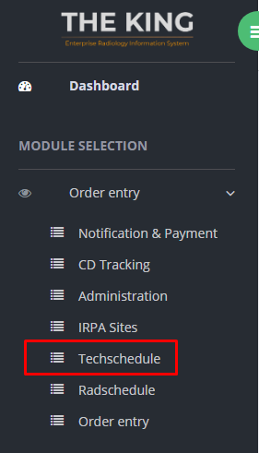

- When calendar option is selected, a window will pop up requesting you to select a modality. Click on a drop-down menu, choose a modality and then click Choose Modality button.

- To create a Break schedule for a specific period of time in a day or multiple days, hold left click on the mouse and select (multiple) time/day. When time is selected, right click and then choose Add Selection.

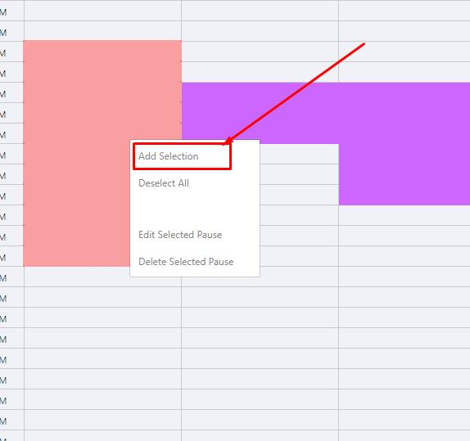

- To add or remove time slots while creating a new break schedule, hold CTRL button and choose separate time slots. You can choose any time slot from any day.

- When you click on Add Selection, a new window will open where you must choose color and type both the name and the description of the break. Also, you can use “Is it Overwritable?” option to allow appointments to be schedule during that break.
- The break schedule template can be used as a default for selected days in the month or just for that current day of the week. If you want to use it as a default template, check Use template as default box.
- Additionally, if you have previously created a same break schedule like the one you are creating now, you can find it in the table at the top of the window. To choose it, click on Pick Pause button. Same setting will be applied to the new break schedule.
- When finished, click on Save Changes button. Confirmation window will appear.
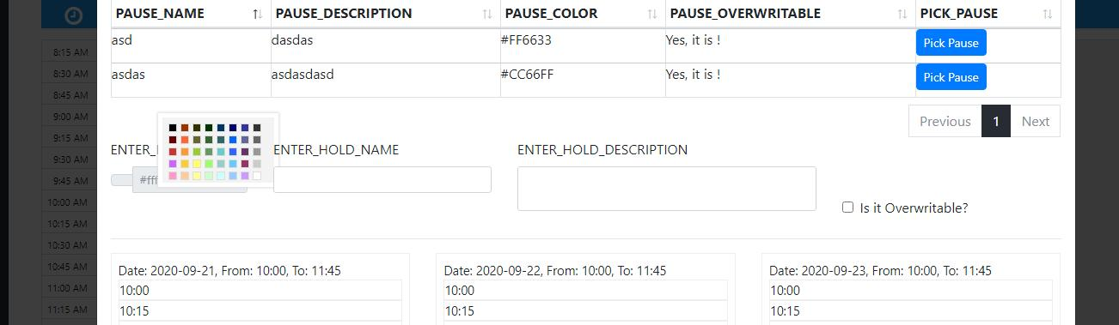

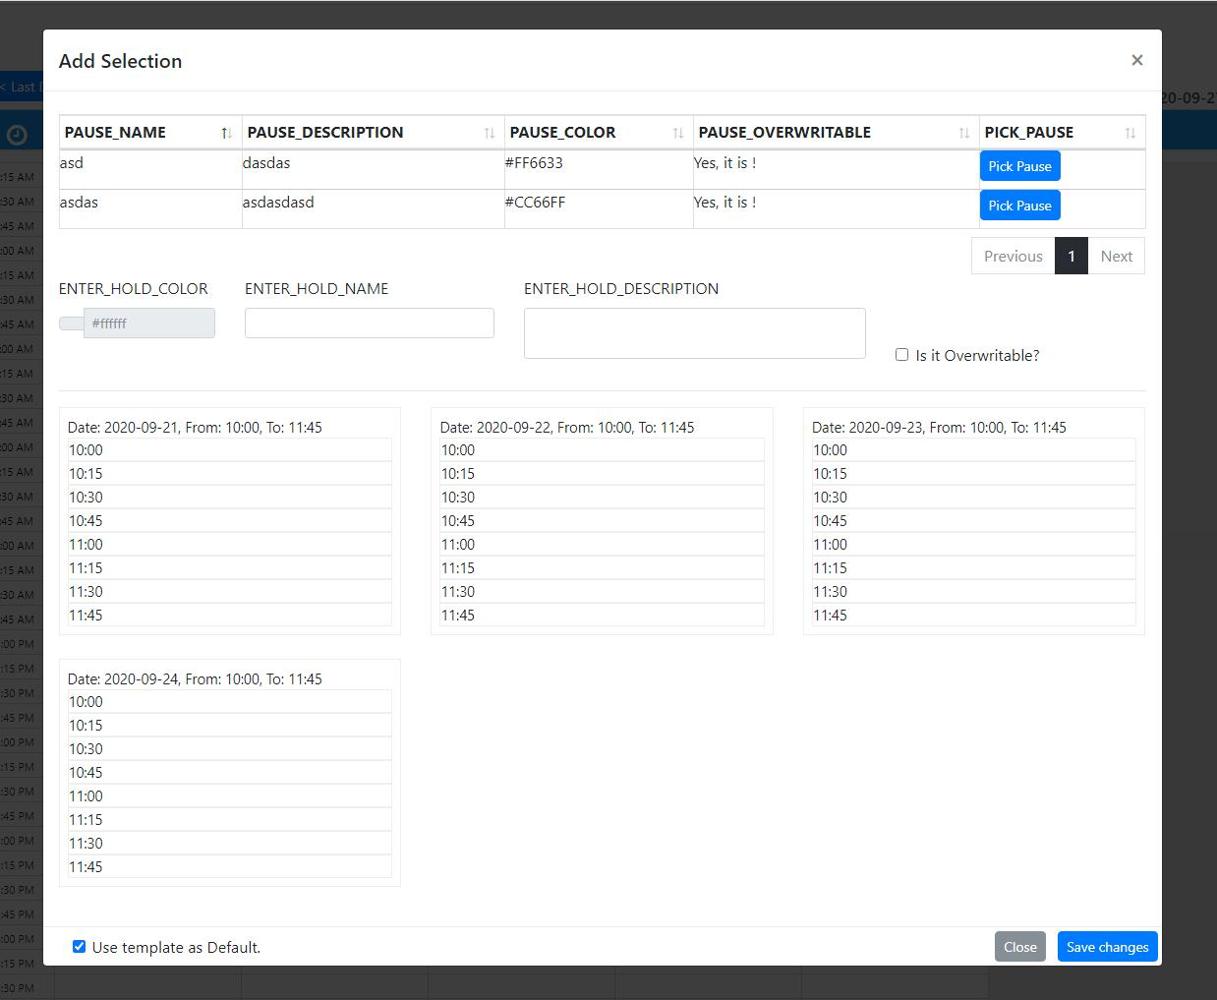

- To add or remove time slots from an existing break schedule, click on the break schedule, hold the CTRL button and select/deselect time slots you want to add/remove. Once selected, use the right click and then choose Edit Selected Pause. New changes will be applied, confirmation window will appear.

- To delete a break schedule, select the break, right click and then choose Delete Selected Pause. Confirmation window will appear.

- To partially delete a break schedule, deselect time slots you want to save (hold CTRL button and click on time slots), select time slots you want delete, right click and then choose Delete Selected pause. Confirmation window will appear.

